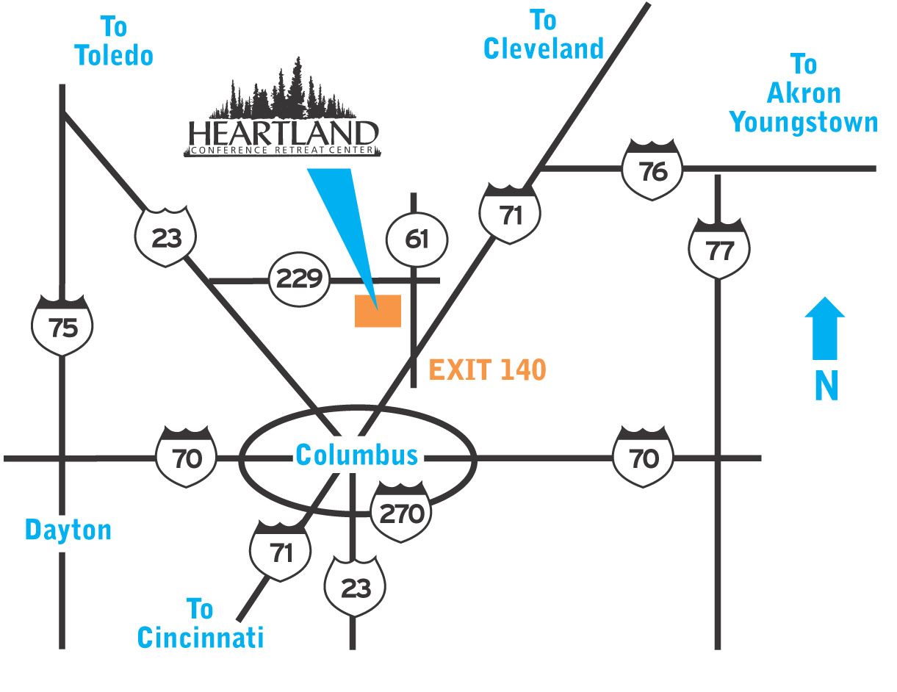

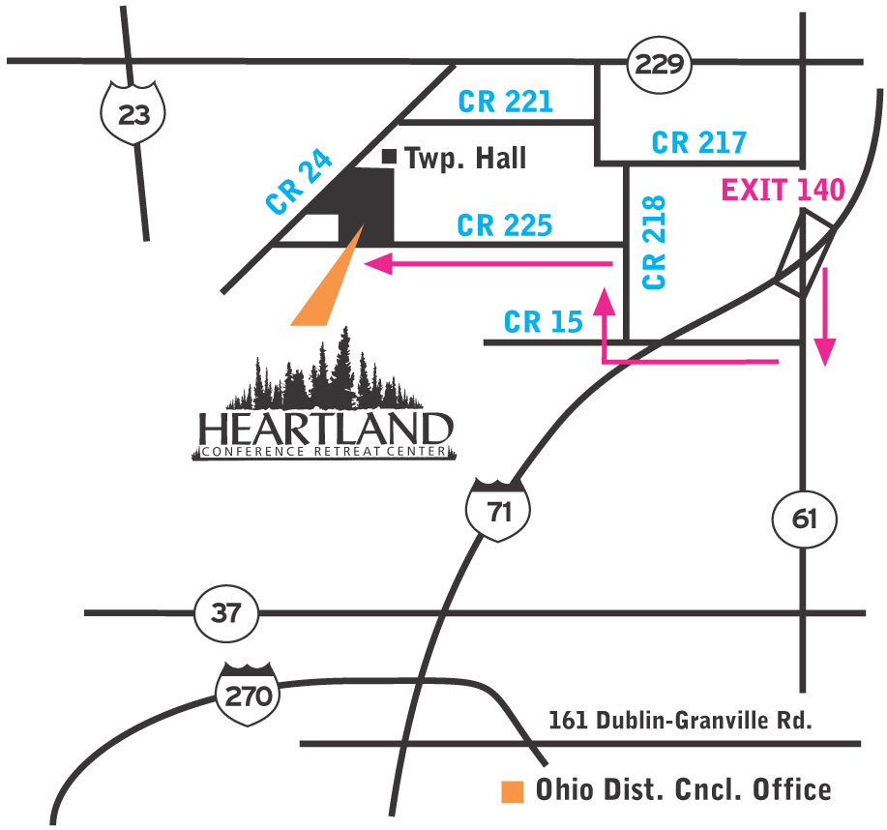

For directions, input the following address at maps.google.com:

Heartland Conference Retreat Center
3201 CR 225
Marengo, Ohio 43334
740-747-0220

