Direct Travel Team
We’re here for you

At Direct Travel, our passion is servicing our traveling partners. Your team is dedicated to just one thing: making sure your travel is efficient, productive and enjoyable as possible. Utilizing your customized online booking tool, available from your desktop or mobile device, will save thousands of dollars each year, while still having contact with your dedicated Travel Team when needed.

Please don’t hesitate to get in touch — we look forward to hearing from you.
Online Booking Technical Support Team

Full Service Kappa Kappa Gamma Travel Team
Call: 888-874-7404/440-205-4310 | Email: kkgoh@dt.com
This is your travel advisory team for the following needs: complex & multi-destination trips, international itineraries, changes to existing bookings, on the road assistance and support

Email: concuroh@dt.com | Call: 800-999-7939
These team members are your online team. Email or call when experiencing with the following: booking questions, assistance through the online reservation process, and troubleshooting.

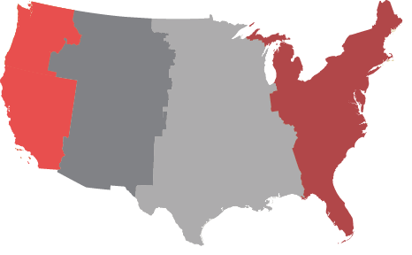
Your Account Management Team
Direct Travel Central Support Sharon Birtley, CTC Terri Folino, CTC, CNE
amcentralsupport@dt.com Director of Corporate Services Director Technology and Operations
440-205-4660 sbirtley@dt.com tfolino@dt.com

Regular Hours of Support
Use the contact information above Monday – Friday during
our regular hours of support.

Pacific Time
5:30a- 2 pm

Mountain Time
6:30a- 3 pm

Central Time
7:30 am – 4 pm

Eastern Time
8:30a– 5 pm

After Hours Emergency Support
Use our emergency services Monday – Friday 5 pm – 8:30 am EST, and all weekends and holidays. Please Note: There is a $18 charge per call. Reminder: It is advised to use the After Hours Emergency Support only for flight interruptions, itinerary changes and other emergencies that cannot wait until normal business hours.
United States International
888-874-7404 (press 1) + 001.203.787.6266

