Kappa Kappa Gamma
Concur Travel News

Dear Kappa Kappa Gamma Travelers,

Our goal, at Direct Travel, is to help you make booking travel easier and life on the road more convenient.

In this issue of Concur Travel News you will find answers to frequently asked questions, information about the free mobile app, TripIt, that is integrated with Concur, as well as travel booking tips and tricks designed to make booking travel and life on the road more convenient and accessible for you from your online Concur booking tool and mobile device.

If you have questions about your online travel tool, please email our team at concuroh@dt.com, or call us at 800-999-7939.
Best Regards,
Your Direct Travel Team.

Concur Travel FAQ's Answered
Our Concur Online Travel Quick Reference Guide will provide online travel customers with at­a­glance answers to common questions about your Concur product.

Recommended Browsers
As Concur continues to enhance and develop new technologies, we want you to be able to take advantage of these enhancements. Direct Travel recommends upgrading to the latest browsers for the best overall experience with Concur products. Having the latest browser version will prevent problems when booking your travel and will allow you to take advantage of new technologies that have been released. For example, use of older browsers, such as Internet Explorer v.6.0 or v.7.0, are supported, but expect a degradation of speed and overall performance as these browsers are not fully compatible with Concur's emerging technologies.

Below is the updated list of supported browser and operating system configurations for Concur Travel & Expense*.

Firefox 22.2 23.0 24.0 | Windows 7 (SP1) Windows Vista (SP2)  Windows XP Professional (SP3) Mac OS X 10.4 or later
Google Chrome | Windows 7 (SP1) Windows Vista (SP2)  Windows XP Professional (SP3) Mac OS X 10.4 or later
Internet Explorer 10.0 | Windows 7 (SP1)  Windows 8
Internet Explorer 9.0 | Windows 7 (SP1) Windows Vista (SP2)
Internet Explorer 8.0 | Windows 7 (SP1) Windows Vista (SP2)  Windows XP Professional (SP3)
Internet Explorer 7.0 | Windows Vista (SP2)  Windows XP Professional (SP3)
Safari 6.0 | Mac OS X Version 10.8 or later
Safari 5.1 | Mac OS X Version 10.5 or later
Safari 5.0.5 | Mac OS X Version 10.5 or later
Safari 4.1.3 | Mac OS X Version 10.5 or later

*Please always check with your IT Department regarding your company's policy before downloading any new software.

Concur Travel Tips ­ "I want to..."
Once you have made a reservation you will have "I want to...." Options.
- Go to Upcoming Trips on the main page of your Travel Center
- Click on the Trip Name/Description you wish to make adjustments to
- Choose the action you want to perform:
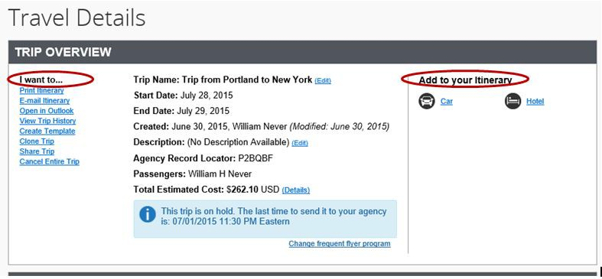

E­mail Itinerary: This option allows you to e­mail your travel itinerary to yourself or to others.

Open in Outlook: Allows you to add your travel plans into your calendar.

Create Template: If you make the same trip often, save time by creating a trip template that will allow you to quickly search and make travel plans for a recurring itinerary without going thought the search process again. Specify the dates you wish to travel on and Concur will create an itinerary specific to your preferences.

Clone Trip: If you are a travel administrator you can clone an existing trip for another person you have administrative rights for. The Clone Trip option will walk you through options such as flights, cars and hotels so people traveling together have the option to share certain aspects of the trip, such as car rental or hotel.

Share Trip: The Share Trip option allows you to send your travel plans to another Concur user you wish to have access to your plans so you can share a trip with them ­ essentially this is cloning without having admin rights to book for another person.

Cancel Entire Trip: Concur now allows travelers to cancel their reservations and will offer the option to VOID your ticket, when applicable. The major carriers, such as Delta, American, US Airways, allow you to VOID your already ticketed reservation if done inside of 24 hours of your ticket being issued. If this option applies to your reservation, you will be asked if you would like to VOID the ticket which will allow you to avoid the change fee! If voiding your ticket does not apply, Direct Travel will store your non­refundable ticket for future use.

Add a car or hotel to your existing trip: On the right of the page simply click on Car or Hotel under Add to your itinerary to make the necessary changes. Direct Travel urges you to book all cars and hotels through Concur Travel, whether you are making a new reservation, or adding to an existing itinerary. In the case of an emergency we will be able to help quickly if we know where you are!

Concur Technical Support is Free!
Your dedicated Concur Technical Support Team, below, is always happy to assist you, so please don't hesitate to give us a call! There is no charge for using Direct Travel's Technical Support for your travel booking questions. Please feel free to email or call when you need help with technical booking questions, assistance with the online reservation process, or troubleshooting.

HOURS OF OPERATION: Monday ­ Friday, 8:00 AM ­ 8:00 PM ET
EMAIL: concuroh@dt.com
CALL: 800-999-7939

